**1.Title: Online Farming Management**



**2.Project Statement:**

The project aims to develop a user-friendly web application that facilitates and the aim of this project is to develop an agricultural information system provides its users and researches to get online information about, the crop, statistical details and new tendencies. The trends of the crops act so that these will be pretty important to the users who access these via the Internet. The main features of the information system includes information retrieval facilities for users from anywhere in the form of obtaining statistical information about fertilizer, research institutes and researches, land availability, diseases, suitable soil concentration for the corresponding crops, statistical information about exports and etc.

l**Outcomes:**

Developed countries are using Management Information System to assist deferent task for their end users or clients. Other than that developing countries have to provide Information for their peoples who interested in Economy. For that we need Information System to cater them for various ways. This agricultural system assist deferent users as Planters, Importers Exporters Prospective investors ,and Researchers

1. **Modules to be implemented**
2. User Authentication and Registration
3. Appointment Scheduling Interface
4. Seed and Machinery Availability Management
5. Farming Information Management
6. Sales Management
7. Notification System
8. Admin Dashboard
9. **Week-wise module implementation and high-level requirements with output screenshots**

**Milestone 1: Weeks 1-3**

**Module 1: User Authentication and Registration**

* Implement user registration functionality.
* Develop user login mechanism.
* Integrate email verification and password reset features.
* Output screenshoot:

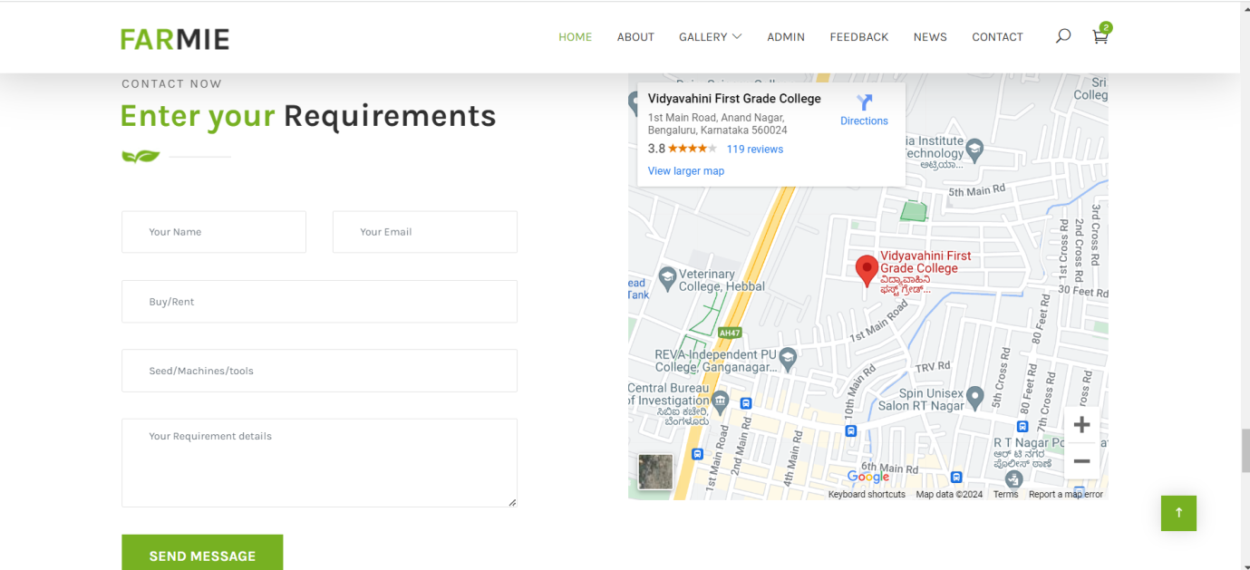

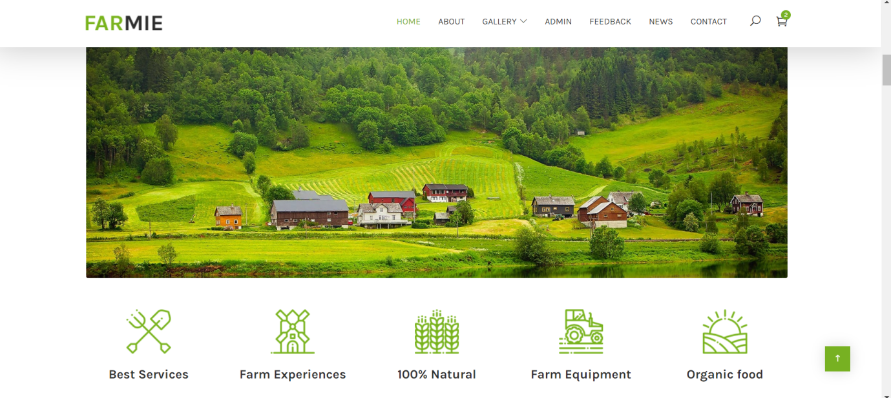

**Module 2: Appointment Scheduling Interface**

* Design database schema for storing table availability information.
* Develop an interface for crop management to set their availability.
* Implement backend functionality to manage and update expert availability.
* Output screenshot

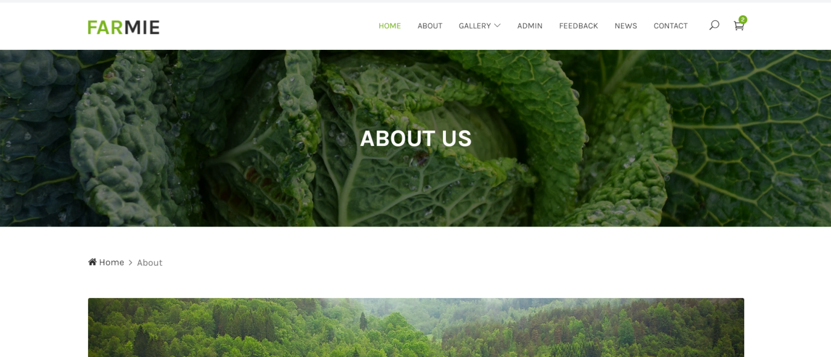

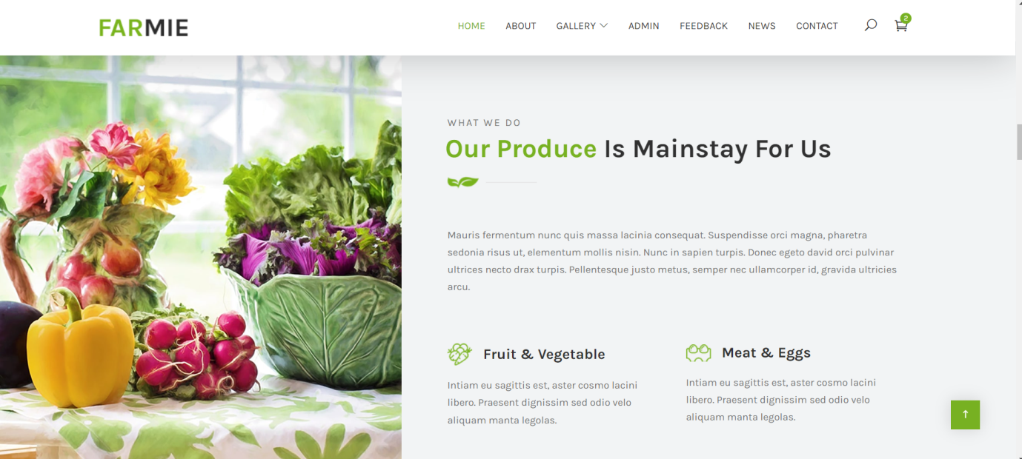

**Milestone 2: Weeks 4-5**

**Module 3: Seed and Machinery Information Interface**

* Design and develop the interface for Seed and Machinery Information.
* Implement functionality for users to select menu, preferred time slots.
* Integrate the scheduling interface with the backend for storing farmer seed and machinery details.
* Output screenshot

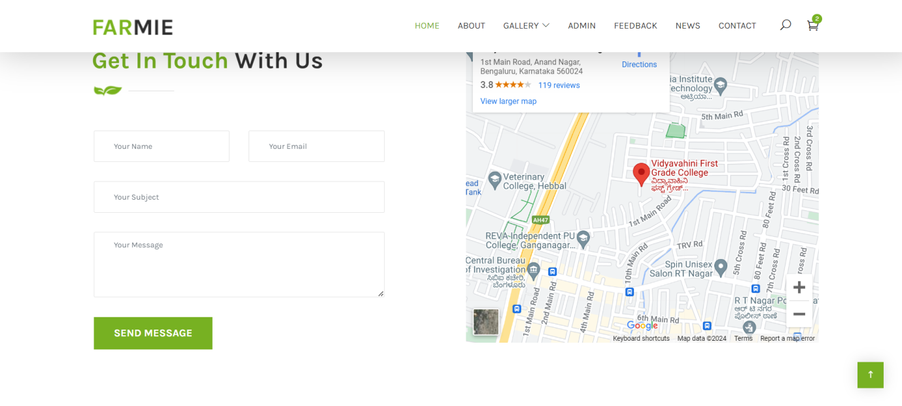



**Milestone 3: Weeks 6-7**

**Module 4: Farming Information Management**

* Design database schema for farmer and expert appointment details.
* Implement backend functionality for scheduling farmer and expert slot booking and preventing conflicts.
* Develop an interface for farmer and expert to view and manage appointments.
* Output Screenshot:

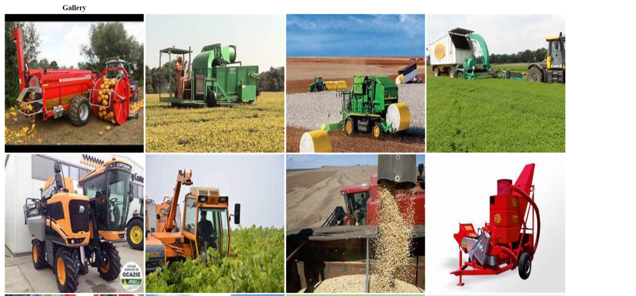

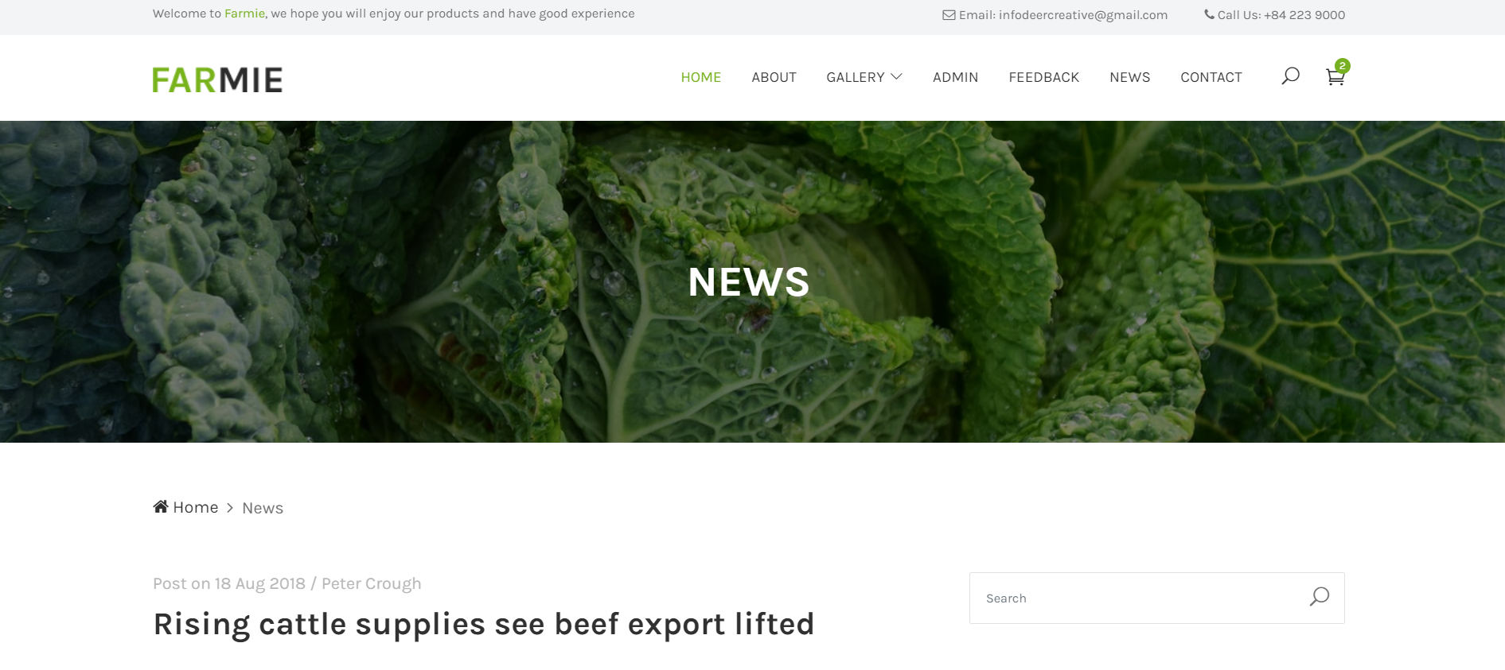

**Milestone 4: Weeks 8-10**

**Module 5: Sales Information Management**

* Design database schema for storing farmers sales information .
* Develop functionality for farmer to provide and update their information.
* Implement backend logic for accessing and managing customer information securely.
* Output Screenshot:

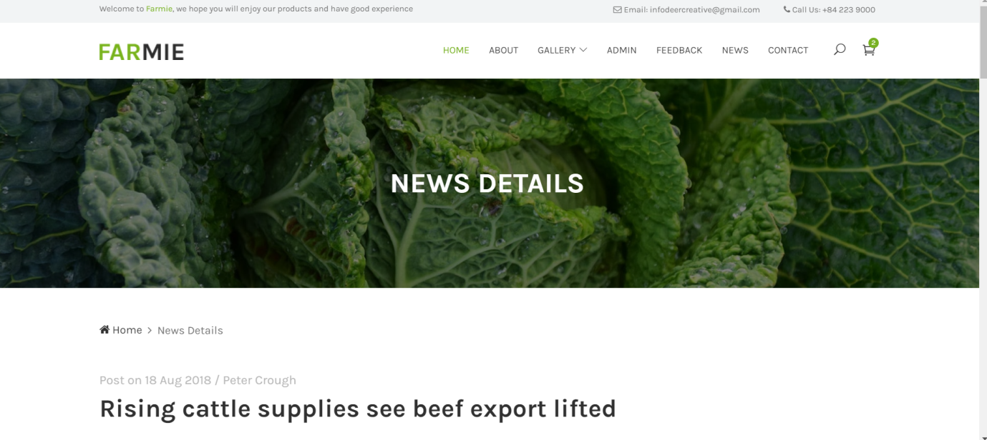

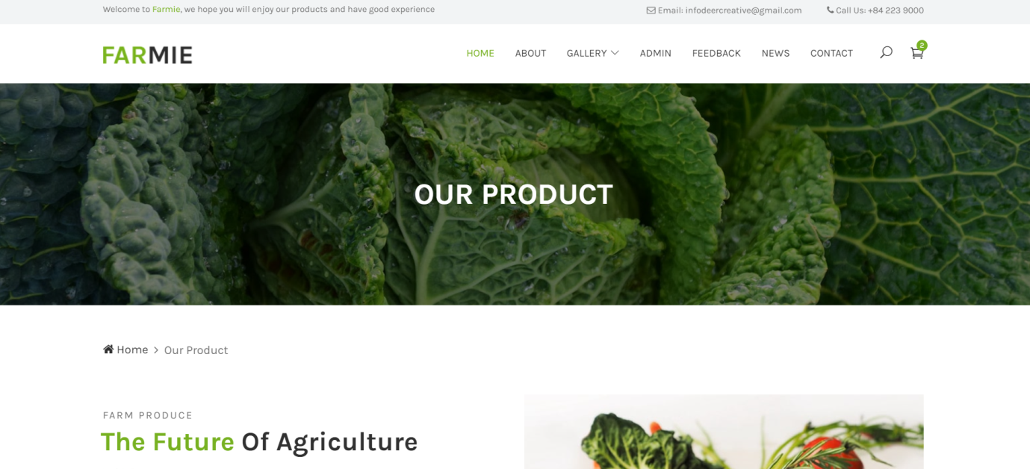

**Module 6: Notification System**

* Integrate email and/or SMS notification services.
* Develop triggers and notifications for appointment reminders, new bookings, and cancellations.
* Implement a system for handling and tracking notifications.
* Output screenshot:

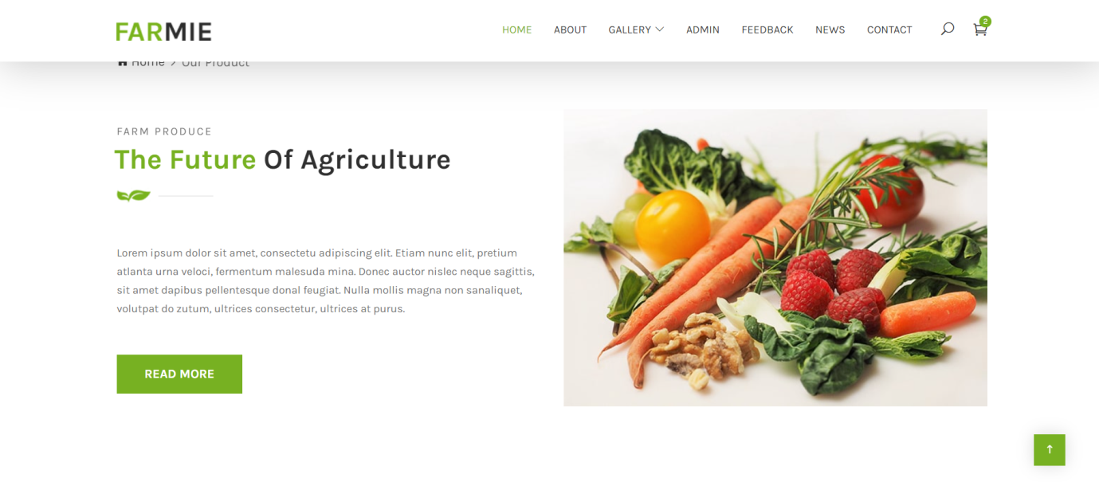

**Module 7: Admin Dashboard**

* Design the layout and functionality of the admin dashboard.
* Implement user management features for admins to add, edit, and delete users.
* Develop modules for managing experts, appointments, and farmer information.
* Output Screenshot:

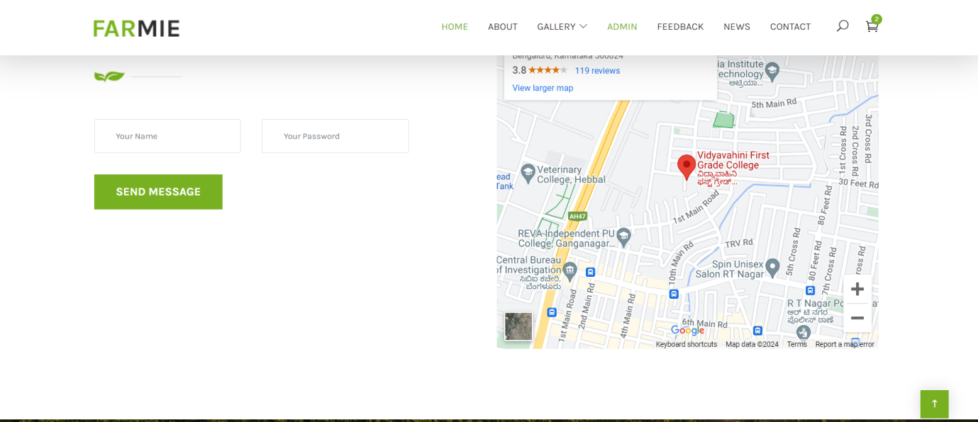

**Evaluation Criteria:**

**Milestone 1 Evaluation (Week 3):**

* Completion of user authentication and registration.
* Successful implementation of table availability management functionalities.

**Milestone 2 Evaluation (Week 5):**

* Appointment scheduling interface is fully developed and integrated with the backend.

**Milestone 3 Evaluation (Week 7):**

* Appointment management system is operational, allowing for scheduling and viewing table booking.

**Milestone 4 Evaluation (Week 10):**

* Customer information management, notification system, and admin dashboard are fully implemented and functional.

1. Design diagrams

Class Diagram: Entity classes

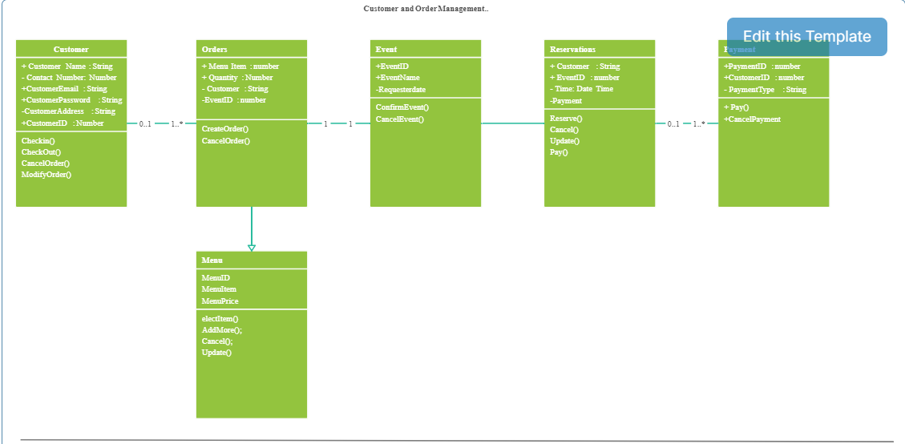

**Output Screenshots:**

1. Dashboard



2. Admin Dashboard

